Name

Mathematics Stage 5 Core
Negative Indices

Book 1 | Apply index laws to numerical expressions with negative-integer indices | Version: 260419  Feedback:  https://MrDingMaths.com
Contents
Syllabus Content 2
Learning Intention 3

Syllabus Content
MA5-IND-C-01 simplifies algebraic expressions involving positive-integer and zero indices, and establishes the meaning of negative indices for numerical bases
Apply index laws to numerical expressions with negative-integer indices
- Apply index notation, patterns and index laws to establish the meaning of negative indices for numerical bases
- Evaluate numerical expressions involving a negative index by first representing them with a positive index
- Represent given numbers in index form (integer indices and bases only) and vice versa

The Negative Index

- Review
- Simplify expressions using division index law
- $5^{3}÷5^{7}$ | - $3÷3^{5}$ | - $2^{4}÷2^{9}$

- Recall zero index
- $3^{0}$ | - $x^{0}$ | - $3x^{0}$

- Investigation Negative indices
Evaluate the following:
$$5^{3}=$$  $$5^{2}=$$  $$5^{1}=$$  $$5^{0}=$$  $$5^{-1}=$$  $$5^{-2}=$$  $$5^{-3}=$$ | $$3^{-1}=$$  $$4^{-1}=$$  $$5^{-1}=$$  $$6^{-1}=$$ |  | $$3^{-2}=$$  $$4^{-2}=$$  $$5^{-2}=$$  $$6^{-2}=$$
For any non-zero number $a$, $a^{-n}=$ ……………
$\frac{1}{a^{n}}$ can be written as …………

Show why this is true using:
Division index law  $$7^{3}÷7^{5}=$$ |  | Fractions  $$\frac{7^{3}}{7^{5}}\frac{÷7^{3}}{÷7^{3}}=$$

- Index Law of Negative Powers
$$a^{-n}=\frac{1}{a^{n}}$$

- Write negative powers as a positive power
$$6^{-1}$$  $$=\frac{1}{6^{1}}$$ | $$3^{-4}$$  $$=\frac{1}{3^{4}}$$ | $${10}^{-3}$$  $$=\frac{1}{{10}^{3}}$$
Rewrite these numbers in index form using a positive power.
- $2^{-5}$ | - $7^{-2}$ | - $4^{-3}$
- $5^{-9}$ | - $3^{-100}$ | - ${100}^{-3}$

- Example Evaluate numbers with a negative power
$$2^{-3}$$  $$=\frac{1}{2^{3}}$$  $$=\frac{1}{8}$$ | $${10}^{-2}$$  $$=\frac{1}{{10}^{2}}$$  $$=\frac{1}{100}$$

- Guided Practice
Evaluate these numbers.
- $5^{-2}$  $$\frac{1}{25}$$ | - ${10}^{-3}$  $$\frac{1}{1000}$$
- $3^{-4}$  $$\frac{1}{81}$$ | - $4^{-2}$  $$\frac{1}{16}$$

- Key Ideas
- $a^{-n}=$ …………

Foundation
- Complete these tables.
$$÷2$$
$$÷2$$
$$÷2$$
Expression | $$2^{4}$$ | $$2^{3}$$ | $$2^{2}$$ | $$2^{1}$$ | $$2^{0}$$ | $$2^{-1}$$ | $$2^{-2}$$ | $$2^{-3}$$ | $$2^{-4}$$
Number | 16 | 8 | 4 | 2 | 1 | $$\frac{1}{2}$$ | $$\frac{1}{4}$$ | $$\frac{1}{8}=\frac{1}{2^{3}}$$ | $$\frac{1}{16}$$

Expression | $$3^{4}$$ | $$3^{3}$$ | $$3^{2}$$ | $$3^{1}$$ | $$3^{0}$$ | $$3^{-1}$$ | $$3^{-2}$$ | $$3^{-3}$$ | $$3^{-4}$$
Number | 81 | 27 | 9 | 3 | 1 | $$\frac{1}{3}$$ | $$\frac{1}{9}$$ | $$\frac{1}{27}$$ | $$\frac{1}{81}$$

Expression | $$5^{4}$$ | $$5^{3}$$ | $$5^{2}$$ | $$5^{1}$$ | $$5^{0}$$ | $$5^{-1}$$ | $$5^{-2}$$ | $$5^{-3}$$ | $$5^{-4}$$
Number | 625 | 125 | 25 | 5 | 1 | $$\frac{1}{5}$$ | $$\frac{1}{25}$$ | $$\frac{1}{125}$$ | $$\frac{1}{625}$$

Expression | $${10}^{4}$$ | $${10}^{3}$$ | $${10}^{2}$$ | $${10}^{1}$$ | $${10}^{0}$$ | $${10}^{-1}$$ | $${10}^{-2}$$ | $${10}^{-3}$$ | $${10}^{-4}$$
Number | 10000 | 1000 | 100 | 10 | 1 | $$\frac{1}{10}$$ | $$\frac{1}{100}$$ | $$\frac{1}{1000}$$ | $$\frac{1}{10000}$$
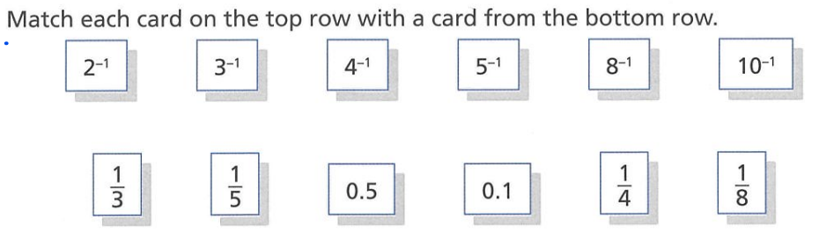

$$2^{-1} 0.5$$
$$3^{-1} \frac{1}{3}$$
$$4^{-1} \frac{1}{4}$$
$$5^{-1} \frac{1}{5}$$
$$8^{-1} \frac{1}{8}$$
$${10}^{-1} 0.1$$
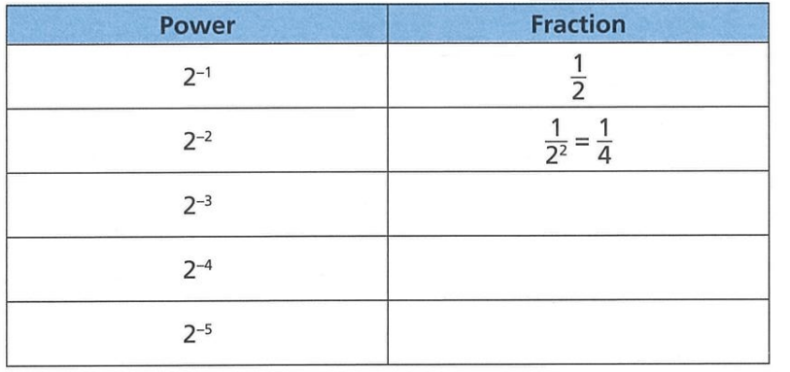
- Complete the table.

$$\frac{1}{8}$$
$$\frac{1}{16}$$
$$\frac{1}{32}$$

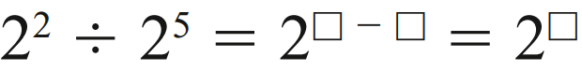
- Complete the following:
  - Simplify using index laws:
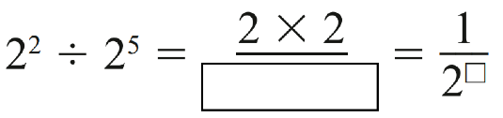
$2^{-3}$
  - Write in expanded form:
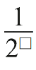
$\frac{1}{2^{3}}$
  - Therefore, $2^{-3}=$
$$2^{-3}=\frac{1}{2^{3}}$$

- Complete the following:
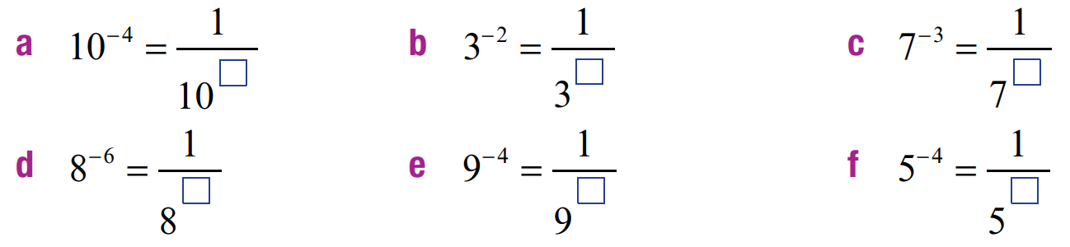  4 | 2 | 3 | 6

- Read the example carefully and answer the questions.
Madeline’s work  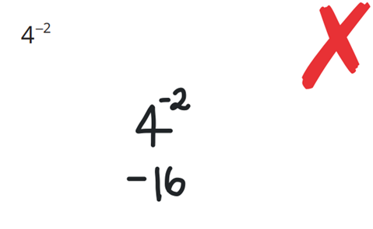  Write as an expression without indices: | How does a negative exponent affect its base?  Negative index means to take the reciprocal of the base  What is the correct answer to this problem?  $$\frac{1}{16}$$  Write as an expression without indices:  $$5^{-3}$$  $$\frac{1}{125}$$

- Rewrite the following as fractions with positive indices.
- $3^{-2}$  $$=\frac{1}{3^{2}}$$ | - $4^{-3}$  $$\frac{1}{4^{3}}$$ | - $2^{-5}$  $$\frac{1}{2^{5}}$$ | - $8^{-2}$  $$\frac{1}{8^{2}}$$
- ${12}^{-1}$  $$\frac{1}{12}$$ | - $9^{-2}$  $$\frac{1}{9^{2}}$$ | - $6^{-1}$  $$\frac{1}{6}$$ | - $7^{-3}$  $$\frac{1}{7^{3}}$$
- $3^{-6}$  $$\frac{1}{3^{6}}$$ | - $2^{-8}$  $$\frac{1}{2^{8}}$$ | - $5^{-1}$  $$\frac{1}{5}$$ | - ${10}^{-5}$  $$\frac{1}{{10}^{5}}$$

Development
- Complete the following to write these expressions as simplified fractions.
$$\frac{1}{2^{3}}=\frac{1}{8}$$ | $$\frac{1}{5^{1}}=\frac{1}{5}$$ | $$\frac{1}{2^{4}}=\frac{1}{16}$$
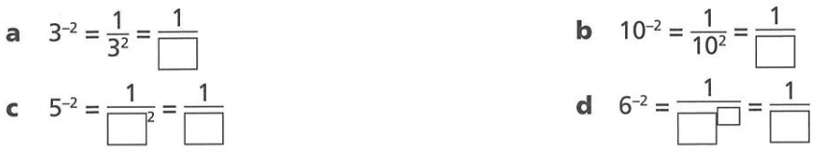  $$\frac{1}{9}$$ | $$\frac{1}{100}$$ | $$\frac{1}{6^{2}}=\frac{1}{36}$$

- Write the following as simplified fractions without powers.
- $3^{-2}$  $$=\frac{1}{3^{2}}=\frac{1}{9}$$ | - $2^{-5}$  $$\frac{1}{32}$$ | - $4^{-3}$  $$\frac{1}{64}$$ | - $5^{-4}$  $$\frac{1}{625}$$
- $6^{-3}$  $$\frac{1}{216}$$ | - $9^{-2}$  $$\frac{1}{81}$$ | - $3^{-4}$  $$\frac{1}{81}$$ | - ${10}^{-4}$  $$\frac{1}{10000}$$
- $2^{-6}$  $$\frac{1}{64}$$ | - $5^{-3}$  $$\frac{1}{125}$$ | - $6^{-2}$  $$\frac{1}{36}$$ | - ${10}^{-3}$  $$\frac{1}{1000}$$
- ${\left(-2\right)}^{-1}$  $$-\frac{1}{2}$$ | - ${\left(-2\right)}^{-2}$  $$\frac{1}{4}$$ | - $-{\left(-2\right)}^{-2}$  $$-\frac{1}{4}$$ | - ${\left(-2\right)}^{-3}$  $$-\frac{1}{8}$$

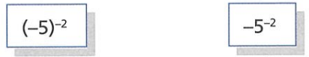
- Explain why these two expressions do not have the same value.

One has the negative raised to the power and the other doesn’t.
$${\left(-5\right)}^{-2}=\frac{1}{{\left(-5\right)}^{2}}=\frac{1}{25}$$
$$-5^{-2}=-\frac{1}{5^{2}}=-\frac{1}{25}$$
- Write the following as decimals.
- $2^{-3}$  $$0.125$$ | - $4^{-1}$  $$0.25$$ | - ${10}^{-2}$  $$0.01$$
- ${25}^{-1}$  $$0.04$$ | - $5^{-2}$  0.04 | - ${\left(-10\right)}^{-2}$  0.01

- Evaluate these expressions.
- $5^{-2}$  $$=\frac{1}{5^{2}}$$  $=$ …… | - $3^{-3}$  $$\frac{1}{27}$$ | - $2^{-5}$  $$\frac{1}{32}$$
- $2^{-4}$  $$\frac{1}{16}$$ | - $6^{-2}$  $$\frac{1}{36}$$ | - ${10}^{-3}$  $$\frac{1}{1000}$$
- $5^{-3}$  $$\frac{1}{125}$$ | - $2^{-3}$  $$\frac{1}{8}$$ | - $3^{-5}$  $$\frac{1}{243}$$
- $4^{-4}$  $$\frac{1}{256}$$ | - ${10}^{-3}$  $$\frac{1}{1000}$$ | - ${10}^{-5}$  $$\frac{1}{100000}$$

- Write each pair of numbers as powers of the given base number.
- 8 and $\frac{1}{8}$ as powers of 2  $$2^{3}, 2^{-3}$$ | - 16 and $\frac{1}{16}$ as powers of 4  $$4^{2}, 4^{-2}$$
- 16 and $\frac{1}{16}$ as powers of 2  $$2^{4}, 2^{-4}$$ | - 25 and $\frac{1}{25}$ as powers of 5  $$5^{2}, 5^{-2}$$
- 125 and $\frac{1}{125}$ as powers of 5  $$5^{3}, 5^{-3}$$ | - 625 and $\frac{1}{625}$ as powers of 5  $$5^{4}, 5^{-4}$$
- 100 and $\frac{1}{100}$ as powers of 10  $${10}^{2}, {10}^{-2}$$ | - 1 000 000 and $\frac{1}{1 000 000}$ as powers of 10  $${10}^{6}, {10}^{-6}$$

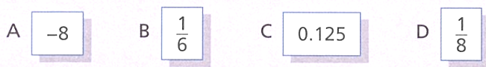
- Mr Ding asks his class to write down the value of $2^{-3}$.
Here are some of his students' answers.

  - Which of the answers are correct?

C and D
  - What mistakes have the other students made?

A: a negative index doesn’t mean to make a positive number negative.
B: They multiplied the power and the index

  - If $2^{10}=1024,$ then $2^{-10}$ is equal to ……………………
$$\frac{1}{1024}$$
  - If $3^{-5}=$ $\frac{1}{243}$, then $3^{5}$ is equal to ………………………
243

- First change each mixed numeral or decimal to a fraction, then simplify the expression.
- ${\left(1\frac{1}{2}\right)}^{-1}$  $$\frac{2}{3}$$ | - ${\left(2\frac{2}{3}\right)}^{-1}$  $$\frac{3}{8}$$ | - ${\left(2\frac{1}{2}\right)}^{-2}$  $$\frac{4}{25}$$ | - ${\left(1\frac{1}{3}\right)}^{-3}$  $$\frac{27}{64}$$
- ${0.2}^{-1}$  $$5$$ | - ${2.25}^{-1}$  $$\frac{4}{9}$$ | - ${2.5}^{-2}$  $$\frac{4}{25}$$ | - ${0.05}^{-2}$  400

Writing Fractions with a Negative Index

- Index Law of Negative Powers
$$\frac{1}{a^{n}}=a^{-n}$$

- Rewrite fractions using a negative power
$$\frac{1}{3^{2}}=3^{-2}$$ |  | $$\frac{1}{7}=7^{-1}$$
Rewrite these fractions using a negative power.
- $\frac{1}{5^{3}}$ | - $\frac{1}{4^{3}}$ |  | - $\frac{1}{2^{6}}$
- $\frac{1}{{10}^{4}}$ | - $\frac{1}{{73}^{12}}$ |  | - $\frac{1}{{12}^{73}}$

- Key Ideas
- We can write fractions using a negative power: $\frac{1}{a^{n}}$ $=$ ……

Foundation
- Find the missing numbers.
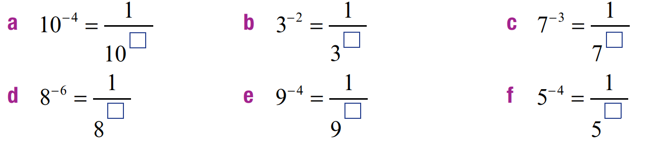  4 | 2 | 3
6 | 4 | 4

- Rewrite these fractions as expressions with negative indices.
- $\frac{1}{2}$  $$2^{-1}$$ | - $\frac{1}{2^{2}}$  $$2^{-2}$$ | - $\frac{1}{2^{8}}$  $$2^{-8}$$ | - $\frac{1}{2^{5}}$  $$2^{-5}$$
- $\frac{1}{5}$  $$5^{-1}$$ | - $\frac{1}{4^{3}}$  $$4^{-3}$$ | - $\frac{1}{3^{4}}$  $$3^{-4}$$ | - $\frac{1}{5^{6}}$  $$5^{-6}$$
- $\frac{1}{6}$  $$6^{-1}$$ | - $\frac{1}{7^{5}}$  $$7^{-5}$$ | - $\frac{1}{4^{9}}$  $$4^{-9}$$ | - $\frac{1}{{10}^{2}}$  $${10}^{-2}$$

- Complete the following:
$$2^{-3}$$ | $$3^{-2}$$ | $$2^{-4}$$ | 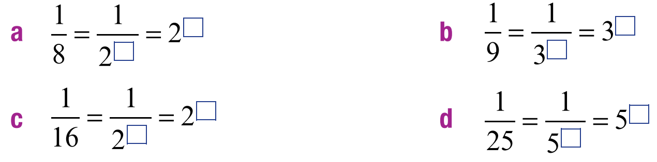  $$5^{-2}$$

- Write these fractions using the smallest possible index. For example, $\frac{1}{8}=\frac{1}{2^{3}}$ $=2^{-3}$
- $\frac{1}{4}$  $$2^{-2}$$ | - $\frac{1}{9}$  $$3^{-2}$$ | - $\frac{1}{125}$  $$5^{-3}$$ | - $\frac{1}{27}$  $$3^{-3}$$

Negative Indices in the Denominator

- Review
- Write negative indices as fractions
- $5^{-3}$ | - $3^{-4}$ | - $7^{-10}$

- Identify the reciprocal of a number
- $\frac{1}{5}$ | - $3$ | - $113$
- $\frac{2}{5}$ | - $\frac{1}{5^{3}}$ | - $6^{5}$

- Investigation Negative index in the denominator
Consider that we have a negative index in the denominator.
$$\frac{1}{5^{-3}}$$
We can find the value of this in two ways:
Find an equivalent fraction  $$\frac{1}{5^{-3}}\frac{×5^{3}}{×5^{3}}$$ | Fraction division  $$\frac{1}{\left(\frac{1}{5^{3}}\right)}=$$
Therefore, we can conclude that:
$$\frac{1}{a^{-n}}=$$

- Index Law of Negative Powers
$$\frac{1}{a^{-n}}=a^{n}$$

- Rewrite negative power in the denominator
$$\frac{1}{5^{-3}}$$  $=5^{3}$ | $$\frac{1}{3^{-4}}$$  $=3^{4}$ | $$\frac{1}{2^{-6}}$$  $=2^{6}$
Rewrite these expressions using positive powers
- $\frac{1}{4^{-2}}$ | - $\frac{1}{3^{-5}}$ | - $\frac{1}{{10}^{-3}}$
- $\frac{1}{7^{-4}}$ | - $\frac{1}{{35}^{-67}}$ | - $\frac{1}{{67}^{-35}}$

- Key Ideas
- If we have a negative index in the denominator, we can write this as: $\frac{1}{a^{-n}}$ $=$ ………

Foundation
- Complete the following:
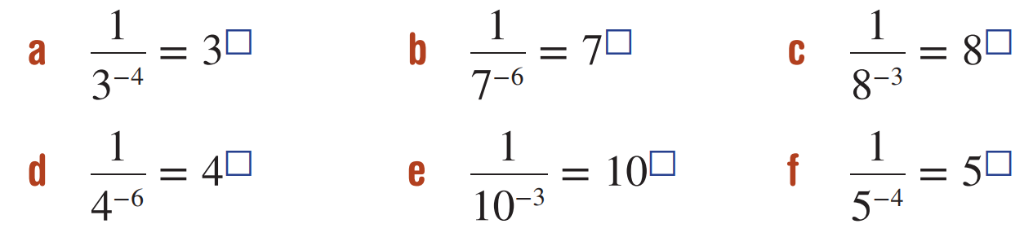  4 | 6 | 3 | 6

- Write the following with positive indices.
- $\frac{1}{3^{-4}}$  $$3^{4}$$ | - $\frac{1}{2^{-7}}$  $$2^{7}$$ | - $\frac{1}{7^{-2}}$  $$7^{2}$$ | - $\frac{1}{6^{-1}}$  6
- $\frac{1}{4^{-5}}$  $$4^{5}$$ | - $\frac{1}{5^{-4}}$  $$5^{4}$$ | - $\frac{1}{5^{-2}}$  $$5^{2}$$ | - $\frac{1}{{77}^{-1}}$  $$77$$

- Simplify, give your answer in positive index form.
$$\frac{1}{3^{-5}}×3^{5}$$  $$3^{5}×3^{5}=3^{10}$$ | $${\left(\frac{1}{3^{-2}}\right)}^{4}$$  $$\frac{1}{3^{-8}}=3^{8}$$

- Find the value of $n$ such that
$$\frac{1}{a^{-n}}= a^{6}$$

$$a^{n}=a^{6}$$
$$n=6$$
- Find the value of $n$ such that
$$\frac{1}{a^{-n}}= a^{-6}$$

$$a^{n}=a^{-6}$$
$$n=-6$$
- Simplify, writing with positive indices
$$\frac{1}{7^{-3}× 7^{-2}}$$

$$\frac{1}{7^{-5}}=7^{5}$$

Mixed Practice

- Index Laws of Negative Indices
$$a^{-n}=\frac{1}{a^{n}}$$ | $$\frac{1}{a^{-n}}=a^{n}$$

- Rewrite with a positive index. Do not evaluate.
- $2^{-1}$  $$\frac{1}{2}$$ | - $2^{-3}$  $$\frac{1}{2^{3}}$$ | - $3^{-2}$  $$\frac{1}{3^{2}}$$
- $5^{-2}$  $$\frac{1}{5^{2}}$$ | - $5^{-10}$  $$\frac{1}{5^{10}}$$ | - ${10}^{-5}$  $$\frac{1}{{10}^{5}}$$

- Rewrite with a negative power. Do not evaluate.
- $\frac{1}{{10}^{2}}$  $${10}^{-2}$$ | - $\frac{1}{{10}^{3}}$  $${10}^{-3}$$ | - $\frac{1}{5^{3}}$  $$5^{-3}$$
- $\frac{1}{2^{3}}$  $$2^{-3}$$ | - $\frac{1}{3^{2}}$  $$3^{-2}$$ | - $\frac{1}{{100}^{2}}$  $${100}^{-2}$$

- Rewrite with a positive power. Do not evaluate.
- $\frac{1}{4^{-3}}$  $$4^{3}$$ | - $\frac{1}{4^{-1}}$  $$4$$ | - $\frac{1}{4^{-10}}$  $$4^{10}$$
- $\frac{1}{7^{-10}}$  $$7^{10}$$ | - $\frac{1}{{10}^{-7}}$  $${10}^{7}$$ | - $\frac{1}{{10}^{-1}}$  $$10$$

- Write with a positive power. Do not evaluate.
- $2^{-1}$  $$\frac{1}{2}$$ | - $\frac{1}{2^{-1}}$  $$2^{-1}$$ | - $2^{-3}$  $$\frac{1}{2^{-3}}$$ | - $\frac{1}{2^{-3}}$  $$2^{3}$$
- $5^{-3}$  $$\frac{1}{5^{3}}$$ | - $\frac{1}{5^{-3}}$  $$5^{3}$$ | - $\frac{1}{7^{-3}}$  $$7^{3}$$ | - $7^{-3}$  $$\frac{1}{7^{3}}$$
- $7^{-5}$  $$7^{5}$$ | - ${12}^{-5}$  $$\frac{1}{{12}^{5}}$$ | - $5^{-12}$  $$\frac{1}{5^{12}}$$ | - $\frac{1}{5^{-12}}$  $$5^{12}$$
- $\frac{1}{{12}^{-5}}$  $${12}^{5}$$ | - $\frac{1}{7^{-6}}$  $$7^{6}$$ | - $6^{-7}$  $$\frac{1}{6^{7}}$$ | - $\frac{1}{6^{-7}}$  $$6^{7}$$

- Evaluate, without using a calculator.
- $3^{-2}$  $$\frac{1}{9}$$ | - $\frac{1}{5^{3}}$  $$\frac{1}{125}$$ | - $\frac{1}{4^{2}}$  $$\frac{1}{16}$$ | - $2^{-4}$  $$\frac{1}{16}$$
- $\frac{1}{3^{-1}}$  $$3$$ | - $\frac{1}{2^{3}}$  $$\frac{1}{8}$$ | - $5^{-1}$  $$\frac{1}{5}$$ | - $\frac{1}{{10}^{-2}}$  $$100$$
- $\frac{1}{6^{2}}$  $$\frac{1}{36}$$ | - $4^{-2}$  $$\frac{1}{16}$$ | - $\frac{1}{2^{-4}}$  $$16$$ | - $\frac{1}{5^{3}}$  $$\frac{1}{125}$$
- ${10}^{-1}$  $$\frac{1}{10}$$ | - $\frac{1}{3^{-3}}$  $$27$$ | - $\frac{1}{4^{1}}$  $$\frac{1}{4}$$ | - $6^{-2}$  $$\frac{1}{36}$$
- $\frac{1}{{10}^{-3}}$  $$1000$$ | - $\frac{1}{3^{2}}$  $$\frac{1}{9}$$ | - $2^{-3}$  $$\frac{1}{8}$$ | - $\frac{1}{6^{-1}}$  $$6$$

Negative Indices with Coefficients

- Index Laws of Negative Indices
When a coefficient multiplies an expression with a negative index, apply the rule to the number with a negative index only.
$$c×a^{-n}=\frac{c}{a^{n}}$$ | $$\frac{c}{a^{-n}}=c×a^{n}$$

- Rewrite using a positive index
$$4×3^{-2}$$  $$=4×\frac{1}{3^{2}}$$  $$=\frac{4}{3^{2}}$$ | $$4×3^{-5}$$  $$=4×\frac{1}{3^{5}}$$  $$=\frac{4}{3^{5}}$$ | $$10×8^{-5}$$  $$=10×\frac{1}{8^{5}}$$  $$=\frac{10}{8^{5}}$$
Write using a positive index
- $3×5^{-9}$ | - $2×3^{-9}$ | - $-4×2^{-5}$
- $5^{-3}×2$ | - $7^{-2}×3$ | - $-3×2^{-1}$

- Rewrite using a negative index
$$\frac{5}{3^{2}}$$  $$=5×3^{-2}$$ | $$\frac{5}{3^{9}}$$  $$=5×3^{-9}$$ | $$\frac{12}{5^{9}}$$  $$=12×5^{-9}$$
Write using a positive index
- $\frac{3}{4^{2}}$ | - $\frac{9}{4^{2}}$ | - $\frac{-1}{4^{2}}$
- $-\frac{1}{4^{2}}$ | - $\frac{-7}{{13}^{5}}$ | - $\frac{7}{{13}^{5}}$

- Rewrite using a positive index
$$\frac{5}{3^{-2}}$$  $$=5×3^{2}$$ | $$\frac{5}{6^{-2}}$$  $$=5×6^{2}$$ | $$\frac{11}{6^{-7}}$$  $$=11×6^{7}$$
Write using a positive index
- $\frac{3}{4^{-2}}$ | - $\frac{6}{5^{-3}}$ | - $\frac{4}{3^{-5}}$
- $\frac{-4}{3^{-5}}$ | - $\frac{-7}{{13}^{-5}}$ | - $\frac{12}{5^{-1}}$

- Example Evaluate expressions with negative indices
$$\frac{3}{2^{-1}}$$  $$=3×2$$  $$=6$$ | $$4×3^{-2}$$  $$=\frac{4}{3^{2}}$$  $$=\frac{4}{9}$$

- Guided Practice
- $3×5^{-2}$  $$\frac{3}{25}$$ | - $\frac{5}{3^{-2}}$  $$45$$
- $\frac{3}{4^{-2}}$  $$48$$ | - $7×3^{-2}$  $$\frac{7}{9}$$

- Key Ideas
- $5×3^{-7}=$
- $\frac{5}{3^{7}}$ $=$
- $\frac{5}{3^{-7}}$ $=$

Development
- Write the following as simplified fractions. Leave your answer with indices.
- $3×2^{-3}$  $$=3×\frac{1}{2^{3}}$$  $=$ ……………  $$\frac{3}{2^{3}}$$ | - $5×2^{-3}$  $$\frac{5}{2^{3}}$$ | - $-2×5^{-2}$  $$-\frac{2}{5^{2}}$$ | - $5×3^{-4}$  $$\frac{5}{3^{4}}$$
- $12×3^{-5}$  $$\frac{12}{3^{5}}$$ | - $9×7^{-2}$  $$\frac{9}{7^{2}}$$ | - $2×7^{-5}$  $$\frac{2}{7^{5}}$$ | - $-3×5^{-4}$  $$-\frac{3}{5^{4}}$$

- Rewrite the following with positive indices.
- $\frac{6}{4^{-3}}$  $$6×4^{3}$$ | - $\frac{-5}{8^{-2}}$  $$-5×8^{2}$$ | - $\frac{4}{7^{-5}}$  $$4×7^{5}$$ | - $\frac{3}{2^{-5}}$  $$3×2^{5}$$
- $\frac{12}{5^{-4}}$  $$12×5^{4}$$ | - $\frac{6}{{10}^{-3}}$  $$6×{10}^{3}$$ | - $\frac{-7}{9^{-4}}$  $$-7×9^{4}$$ | - $\frac{7}{{10}^{-6}}$  $$7×{10}^{6}$$

- Write the following as simplified fractions with no indices.
- $3×2^{-3}$  $$=3×\frac{1}{8}$$  $=$ …………… | - $5×4^{-3}$  $$\frac{5}{64}$$ | - $7×5^{-2}$  $$\frac{7}{25}$$ | - $-2×3^{-4}$  $$-\frac{2}{81}$$
- $4×3^{-5}$  $$\frac{4}{243}$$ | - $-9×5^{-2}$  $$-\frac{9}{25}$$ | - $8×7^{-3}$  $$\frac{8}{243}$$ | - $6×5^{-2}$  $$\frac{6}{25}$$

- Write as a simplified fraction.
- $5×{10}^{-4}$  $$\frac{5}{10000}=\frac{1}{2000}$$ | - $1.5×{10}^{-3}$  $$\frac{1.5}{1000}=\frac{3}{2000}$$ | - $3.42×{10}^{-6}$  $$\frac{3.42}{1 000 000}=\frac{1.71}{500 000}=\frac{171}{50 000 000}$$

- Complete each collection of equivalent expressions.
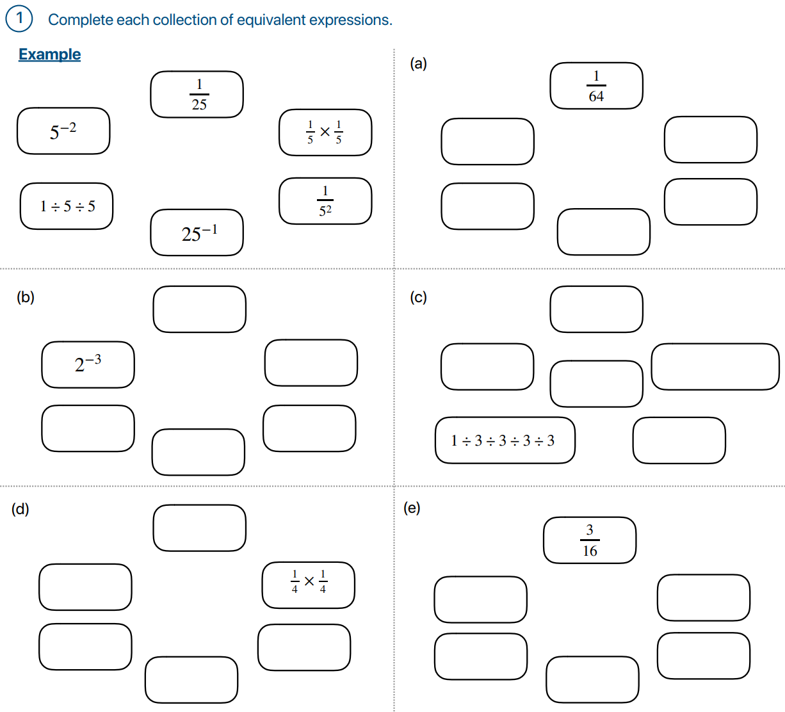  - Example | Clockwise from top:  $$\frac{1}{8}, \frac{1}{2}×\frac{1}{2}×\frac{1}{2}, \frac{1}{2^{3}}, 8^{-1}, 1÷2÷2÷2$$
$$\frac{1}{81}, \frac{1}{3}×\frac{1}{3}×\frac{1}{3}×\frac{1}{3}, \frac{1}{3^{4}}, {81}^{-1}, 3^{-4}$$ | $$3×\frac{1}{2}×\frac{1}{2}×\frac{1}{2}×\frac{1}{2}, \frac{3}{2^{4}}, 3×2^{-4}, 3÷2÷2÷2÷2, 3×2^{-4}$$

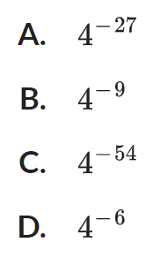
- NAPLAN A
Select the expression that is equivalent to ${\left(4^{-3}÷4^{6}\right)}^{3}$

$${\left(4^{-9}\right)}^{3}$$
$$=4^{-27}$$
A

- Evaluate the following without using a calculator. Write your answer without indices.
- $5^{-1}$  $$\frac{1}{5}$$ | - $3^{-2}$  $$\frac{1}{9}$$ | - ${\left(-4\right)}^{-2}$  $$\frac{1}{16}$$
- $4×{10}^{-2}$  $$\frac{1}{25}$$ | - $-5^{-2}$  $$-\frac{1}{25}$$ | - $-5×{10}^{-3}$  $$-\frac{1}{200}$$
- $6^{4}×6^{-6}$  $$\frac{1}{36}$$ | - $8^{-7}×{\left(8^{2}\right)}^{3}$  $$\frac{1}{8}$$ | - ${\left(5^{2}\right)}^{-1}×{\left(2^{-2}\right)}^{-1}$  $$\frac{4}{25}$$
- $\frac{1}{8^{-1}}$  $$8$$ | - $\frac{1}{{10}^{-2}}$  $$100$$ | - $\frac{-2}{5^{-3}}$  $$-250$$
- $\frac{2}{2^{-3}}$  $$16$$ | - $\frac{-5}{2^{-1}}$  $$-10$$ | - $\frac{2^{3}}{2^{-3}}$  $$64$$
- ${\left(\frac{3}{8}\right)}^{-2}$  $$\frac{64}{9}$$ | - ${\left(\frac{-5}{2}\right)}^{2}$  $$\frac{25}{4}$$ | - $\frac{{\left(3^{-2}\right)}^{3}}{3^{-5}}$  $$\frac{1}{3}$$

